**LAB ASSIGNMENT- 7.4**

**Name**: E. Harini

**Enrollment No:** 2503A51L40

**Course Code**: 24CS002PC215

**Course Title**: AI Assisted Coding

**Lab Number**: 7.4

**BRANCH**: cse

**Lab 7:** Error Debugging with AI – Systematic Approaches to Finding and Fixing Bugs.

**Task1:**  Introduce a buggy Python function that calculates the factorial of a number using recursion.  
Use Copilot or Cursor AI to detect and fix the logical or syntax errors.

**Prompt:** Calculate factorial of 3 using the buggy function.

**Output:**

60

**Observation:**

* The function returns 60 for factorial(5), not the correct value of 120.
* This is because the recursion stops at n == 3 and returns 3, rather than continuing down to 1 .
* The calculation performed is: 5 * 4 * 3 = 60.

**Task2:** Provide a list sorting function that fails due to a type error (e.g., sorting list with mixedintegers and strings).

**Prompt:** Sort the list [ 5,2,9,1,5,6].

**Output**: PS C:\Users\nishc\OneDrive\Pictures\Documents\Desktop\assignment4-wt> & C:\Users\nishc\AppData\Local\Programs\Python\Python312\python.exe c:/Users/nishc/OneDrive/Pictures/Documents/Desktop/assignment4-wt/task7

Traceback (most recent call last):

File "c:\Users\nishc\OneDrive\Pictures\Documents\Desktop\assignment4-wt\task7", line 9, in <module>

print(sort_list(my_list))

^^^^^^^^^^^^^^^^^^

File "c:\Users\nishc\OneDrive\Pictures\Documents\Desktop\assignment4-wt\task7", line 3, in sort_list

return sorted(data)

^^^^^^^^^^^^

TypeError: '<' not supported between instances of 'str' and 'int'

**Code without bug:**

**Output:**

[1,2,5,5,6,9].

**Observation:**

The function sort_ list works correctly because the input list contains only integers, which are comparable, the output is in ascending order.

**Task3:** Write a Python snippet for file handling that opens a file but forgets to close it.

**Prompt:** Write a Python snippet for file handling that opens a file but forgets to close it. using the best practice (e.g., with open() block).

**Code with bugs :** 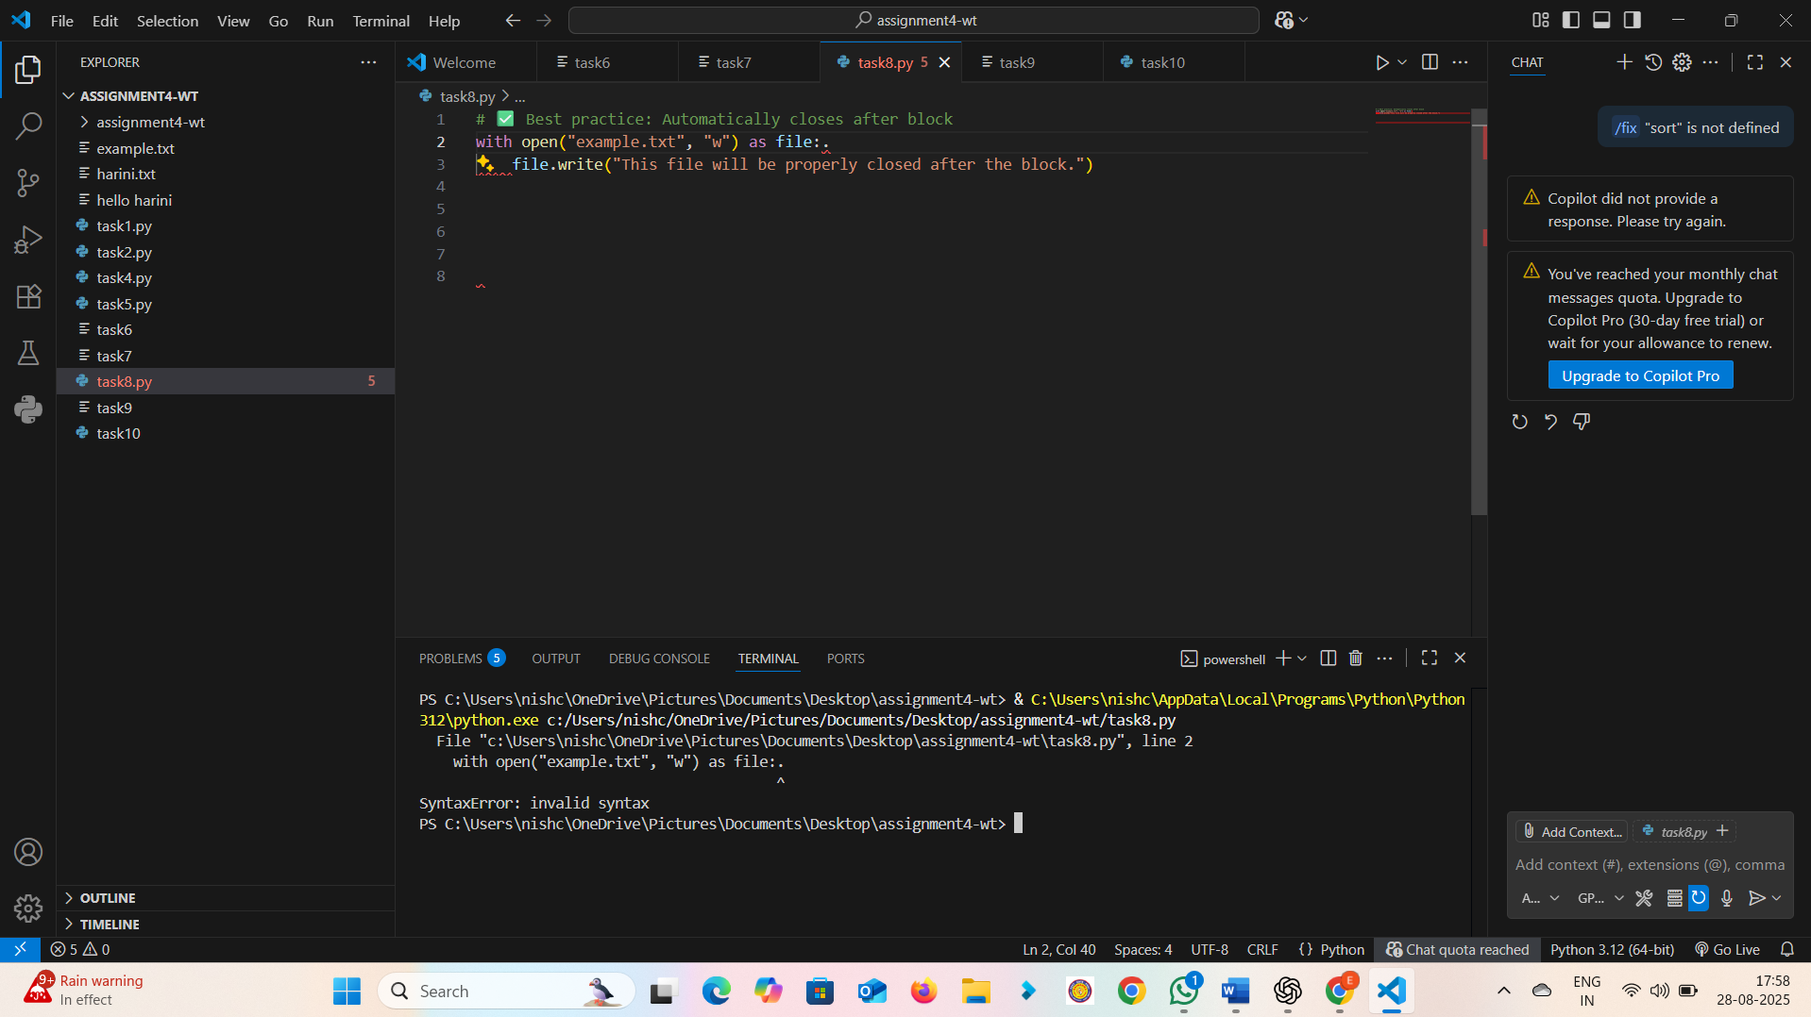

**Output:-**

File "c:\Users\nishc\OneDrive\Pictures\Documents\Desktop\assignment4-wt\task8.py", line 2

with open("example.txt", "w") as file:.

^

SyntaxError: invalid syntax

**Output:**

File content: Hello, this file is safely written and closed!

**Observation:** that using with open() is always safer and preferred over manually opening a file without closing it.

**Task4:**

Provide a piece of code with a Zero Division Error inside a loop. Ask AI to add error handling using try-except and continue execution safely.

**Prompt:** Improve this Python code by adding error handling with try-except so that the loop continues safely even if a division by zero occurs.

**Code with bug:**

**Output:** PS C:\Users\nishc\OneDrive\Pictures\Documents\Desktop\assignment4-wt> & C:\Users\nishc\AppData\Local\Programs\Python\Python312\python.exe c:/Users/nishc/OneDrive/Pictures/Documents/Desktop/assignment4-wt/task9

File "c:\Users\nishc\OneDrive\Pictures\Documents\Desktop\assignment4-wt\task9", line 10

continue.

^

**Output:**

10 / 10 = 1.0

10 / 5 = 2.0

Cannot divide by zero! Skipping 0...

10 / 2 = 5.0

**Observation:** Without error handling → program crashed at zero.

**Task5:**

Include a buggy class definition with incorrect __init__ parameters or attribute references.

**Prompt:** Fix this buggy Python class by correcting the __init__ parameters.

**

**Output:**

PS C:\Users\nishc\OneDrive\Pictures\Documents\Desktop\assignment4-wt> & C:\Users\nishc\AppData\Local\Programs\Python\Python312\python.exe c:/Users/nishc/OneDrive/Pictures/Documents/Desktop/assignment4-wt/task10

Traceback (most recent call last):

File "c:\Users\nishc\OneDrive\Pictures\Documents\Desktop\assignment4-wt\task10", line 13, in <module>

s1.display()

^^^^^^^^^^

AttributeError: 'tuple' object has no attribute 'display'

**Code without bug :**

**Output:**

Name: Harini,

Age: 21

**Observation:** **->** In the buggy version, wrong variable (ag) and wrong attribute (self.name) caused NameError.

-> After fixing __init__ and attribute references, the class works correctly and prints Harini’s details.